**Lab notes**

Contents

Scan procedure 1

Experimental scan 1

Phantom set up 2

VNA Calibration. 6

Bed system set up and BMR software 12

Performing a scan using the bed system. 19

Reconstruction 20

Import datasets 21

Reconstruction Script 21

Speed Search 22

Appendix A 23

References 24

# Scan procedure

## Experimental scan

To perform an experimental scan, there are 3 things that must be set up.

* Prepare phantom to be used.
* Calibrate VNA
* Set up bed system.

We will now discuss each of these steps, and later we will explain how to set up a scan of the phantom.

### Phantom set up

Experimental scans are performed using a breast phantom. In the microwave imaging lab we use two types of phantoms. A hemispherical phantom made of Styrene-acrylonitrile, and a 3D printed phantom made of polycarbonate and printed with Fortus 400mc.

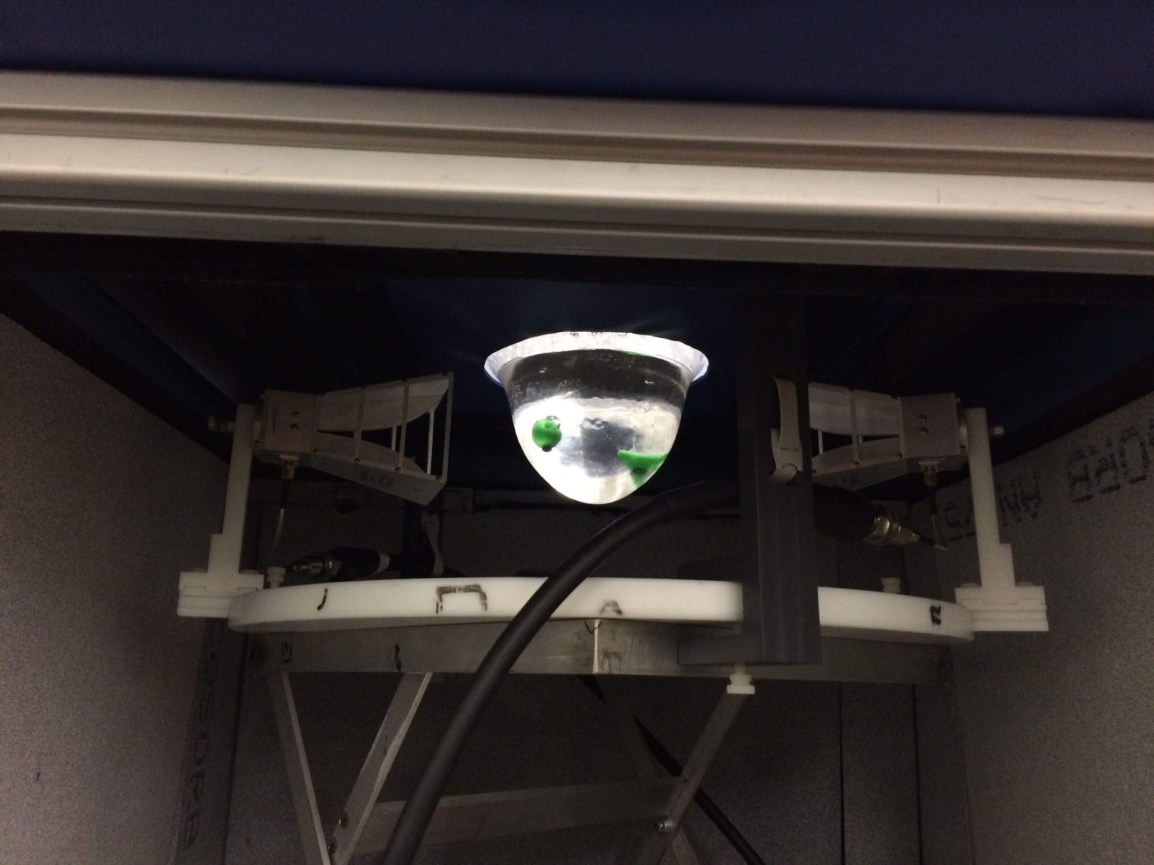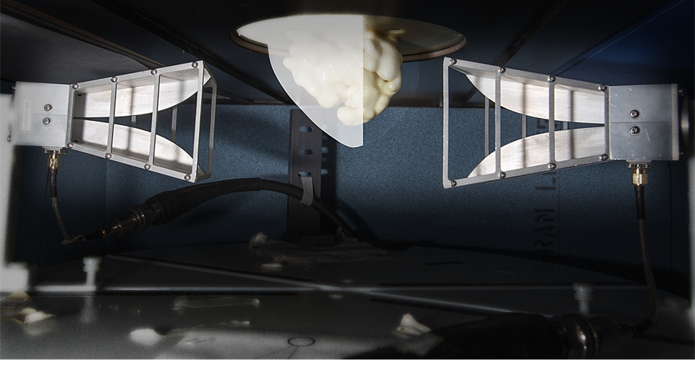

Figure 1 Top: Styrene-acrylonitrile phantom with two fibroglandular patches, bottom: 3D printed phantom with fibroglandular core

The Styrene-acrylonitrile phantoms have a simpler morphology and may not represent a real breast, but they are easy to set up. The 3D printed phantoms are based on MRI images taken from the UWCEM breast phantom repository.

#### Set up of hemispherical phantom.

To set up the Styrene-acrylonitrile phantoms we follow these steps.

1. Fill phantom with Glycerine or Glycerine-water mixture (see appendix 1 for permittivity values). This mixture represents Low-density breast tissue.
   1. When pouring glycerin in the phantom bubbles may form, these bubbles would create a strong scattering response. It is recommended to wait 1 to 3 hours before using the phantom so that the glycerin can settle.
   2. Glycerin may absorb moisture from the air, or release moisture, until it reaches a mixture that is in equilibrium with the relative humidity of the surrounding air [1]. For this reason it is recommended to cover the Glycerin mixture until it is used. This could be achieved using a lid over the phantom or using a plastic wrap tightly secured to the phantom.
2. To create the fibroglandular patches we use TX-151 a polymer in the form of a powder. See Figure 2
   1. Mix the TX-151 with water, 4 parts water for each part of TX-151 (by volume).
   2. Stir the mixture, avoid any lumps of TX-15, the final consistency should be a sticky malleable substance, if the mixture feels wet to the touch keep mixing.
   3. Shape the final mixture in to the desirable form.
   4. The TX-151 loses water to the environment, it is recommended to store the fibroglandular patches in a glycerin bath.
   5. The fibroglandular patches are attached to a plastic rod, rubber O-rings can be used to secure them more firmly.
   6. To place the fibroglandular patches in the phantom a special lid with a grid of gaps is used. The plastic rods can be secured in the lid and the lid can be placed at top of the phantom.
3. A tumor is simulated by a glass bead filled with a saline solution. See Figure 2.
   1. There are some tumors already attached to plastic rods that can be used with the phantom lid.
   2. The tumors can also be attached to a fibroglandular patch. See Figure 2.
   3. Make sure there is no air inside the tumor, any air would create additional scattering and would create an over representation of the tumor.
   4. The empty glass beads can be filled with saline water using a syringe. Hot glue can be used to seal the glass beads.
4. Reference set up: If a reference is needed then remove the tumor and fibroglandular patches from the phantom. Take a scan of the phantom with only glycerine.

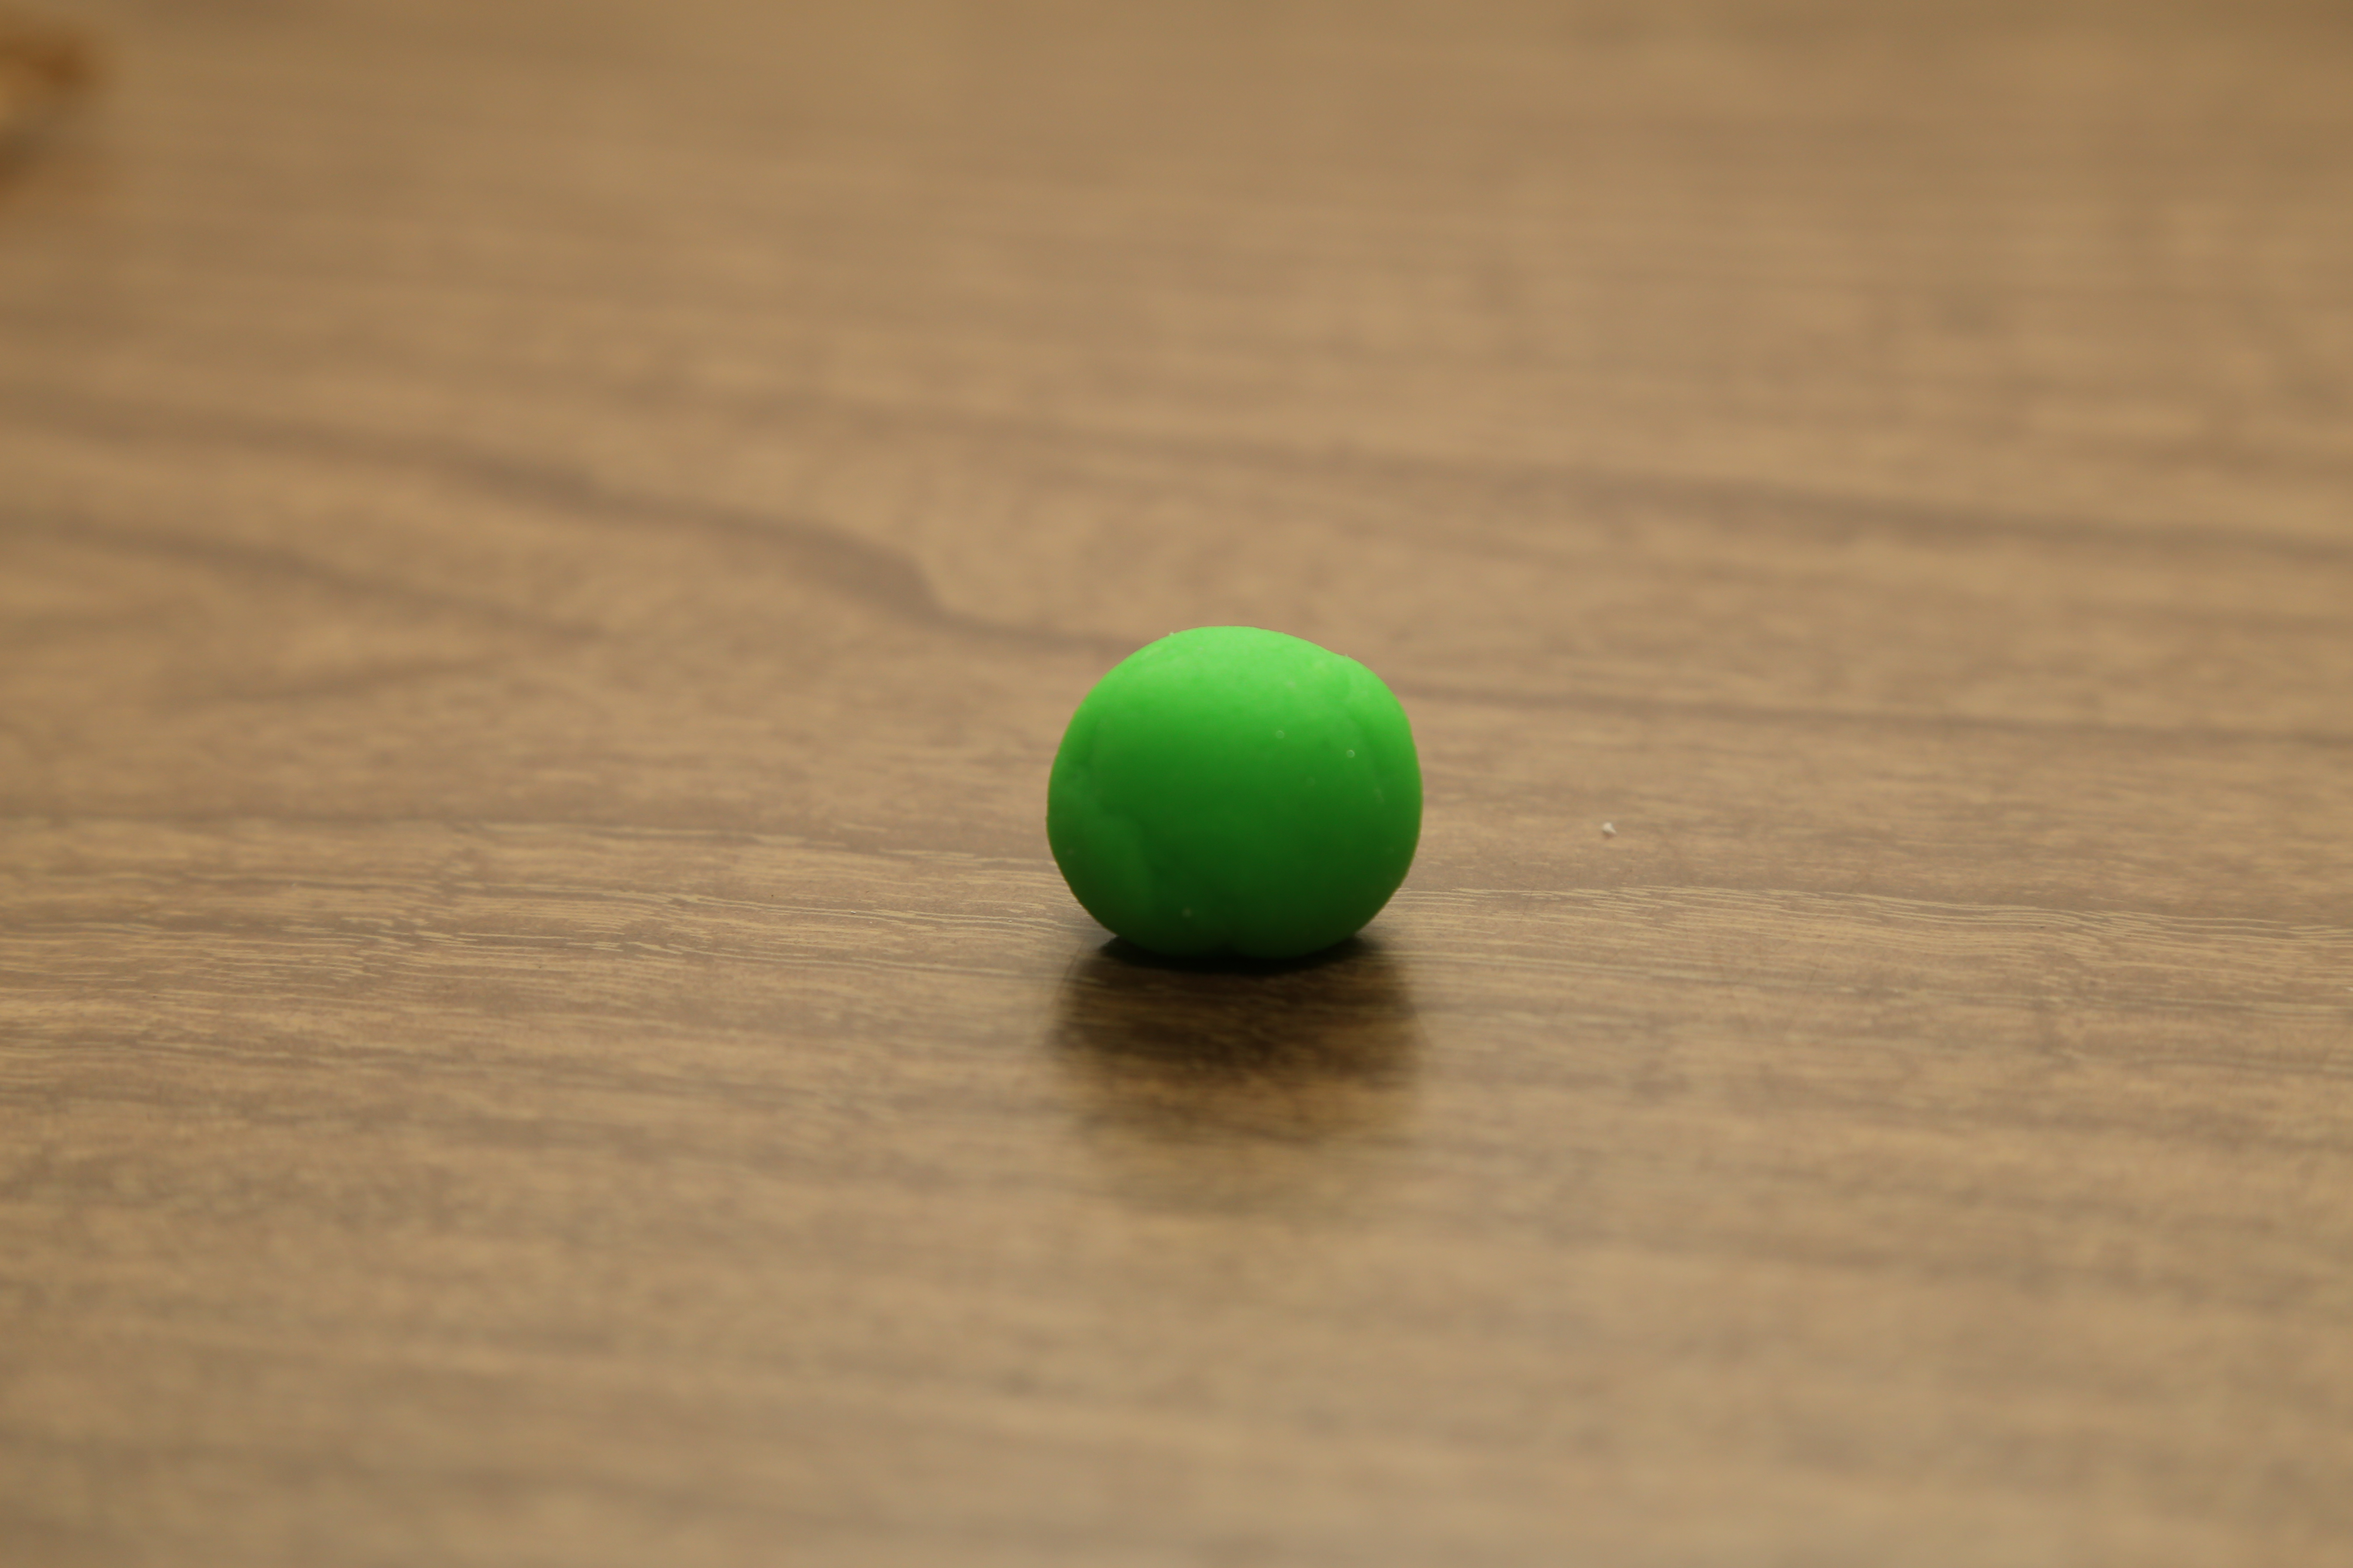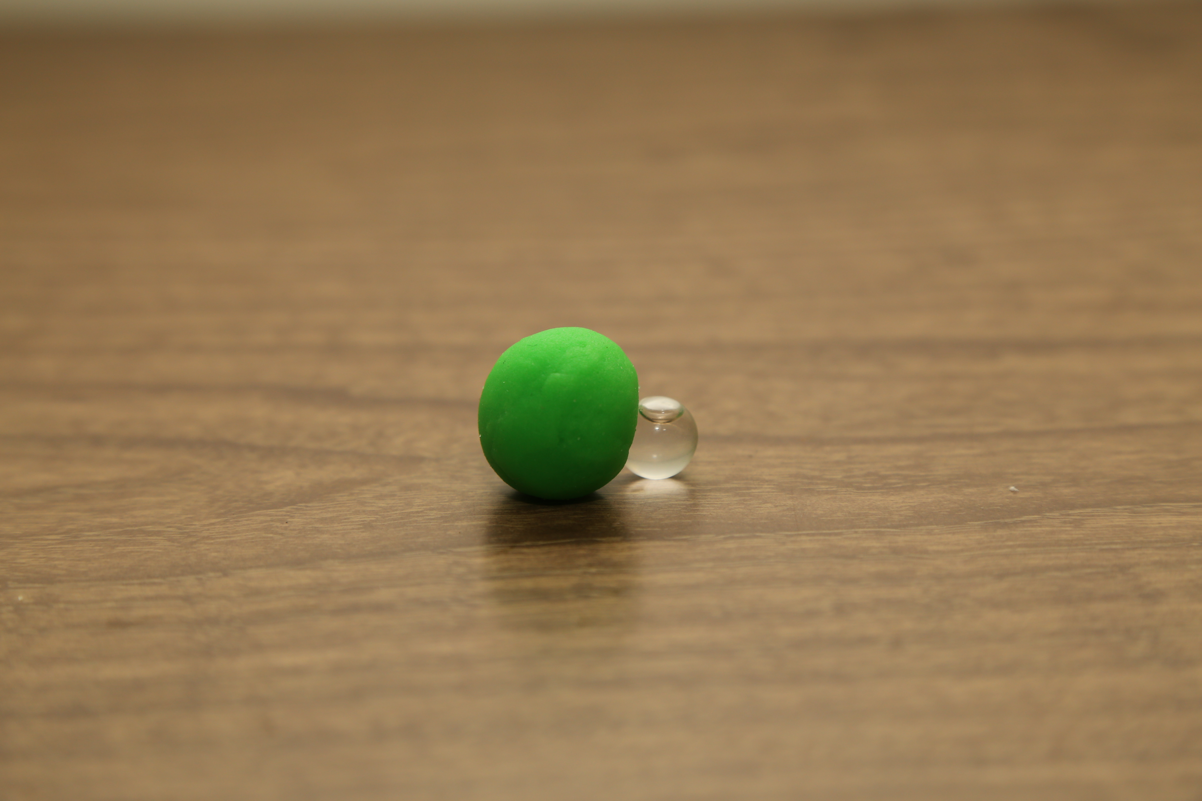

Figure 2 right: Spherical Fibroglandular patch. Left: Fibroglandular patch with glass Tumor attached, note that there is an air bubble, this should be avoided or the tumor will be overrepresented in the final image.

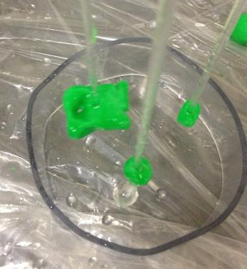

A

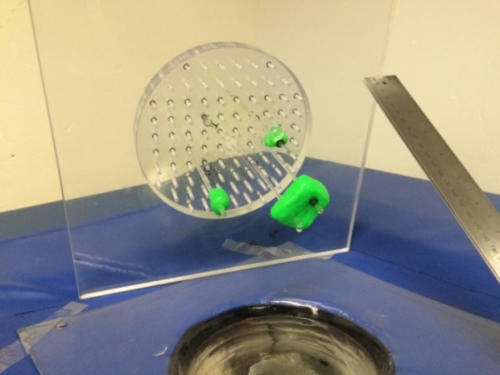

B

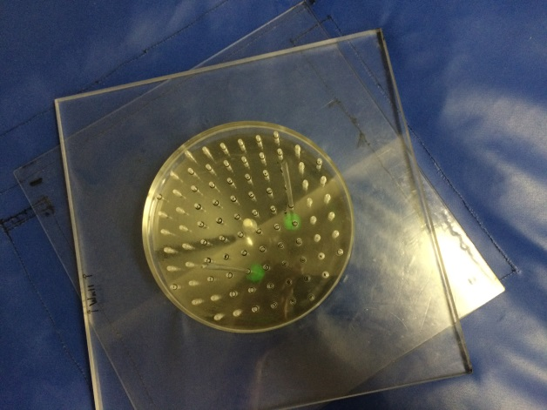

C

Figure 3 A: 3 fibroglandular patches with a tumor attached on one. B: Lid with fibroglandular patches attached, before being lowered in the phantom. C: Top view of the phantom with the lid and fibroglandular patches.

#### Set up for 3D printed phantom

The 3D printed phantoms use a shell system that allows combining different breast sizes with fibroglandular tissue of different densities. Before starting the procedure choose the right combination of shells, make sure that they fit together.

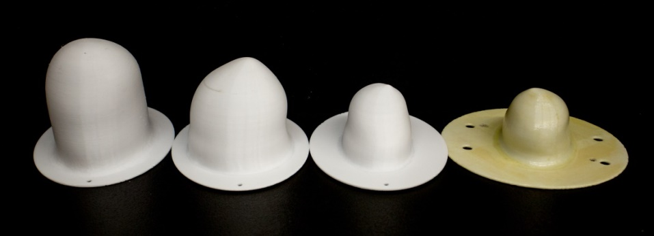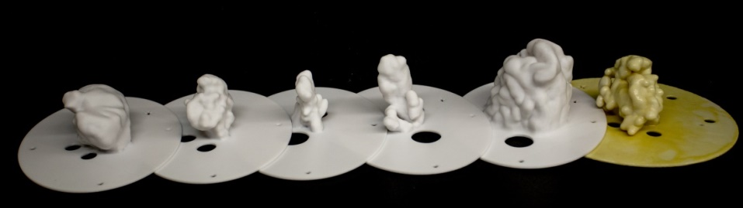

Figure 4 3D printed shells, the different sizes can be combined to create breasts of different densities. Note that the yellowish tint come from an oil based coating to avoid any liquid diffusion. Only use shells that have been treated with coating.

The 3D phantom set up follows these steps.

1. Select the shell sizes to use. Make sure they fit together by aligning the pegs at the outer shell with the openings in the inner fibroglandular shell.
2. Secure the outer shell to the top of the bed system. The hot glue gun may be used for this propose.

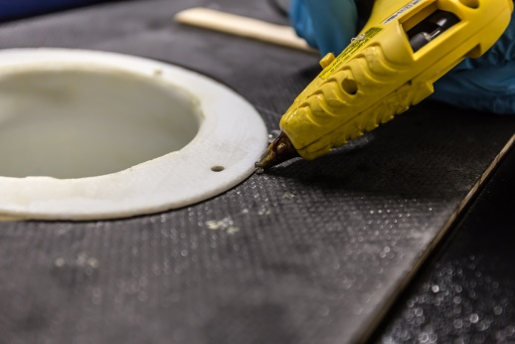

Figure 5 Secure the outer shell using the hot glue gun.

1. To emulate the fibroglandular tissue dielectric properties a mixture of 100 ml and 40 ml Triton X-100 is used.
   1. Adjust the ratio for bigger fibroglandular shells. 5 parts water for every 2 parts of Triton X-100
   2. A stirring hotplate can be used to do the mixture. Once the Triton X-100 and water are in the same beaker place the stir bar inside.
   3. Slowly heat the mixture up to 90 Degrees, and use a speed of 6 or 7 when stirring.
   4. The Triton may form a gelatin like mixture, try to break this using a glass rod, the mixture should be homogeneous and should be a liquid.
   5. Try to avoid any bubbles in the mixture.
   6. The mixture should be stir for at least one hour, and up to 24 hours for optimal results.

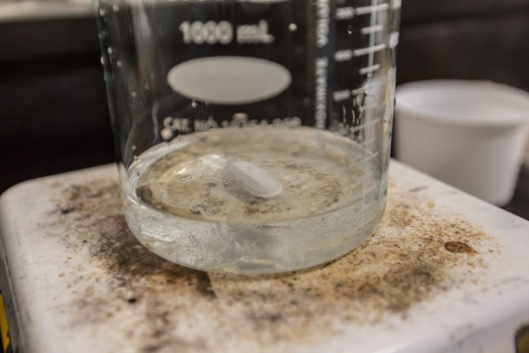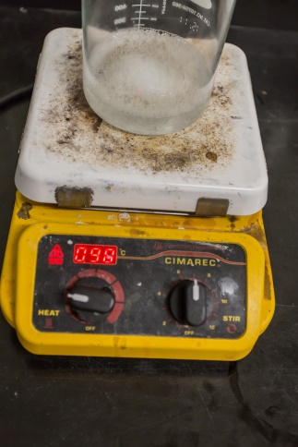

Figure 6 Left: Start of the stirring process, use the big stir bar. Right: end of the stir process. The temperature should not be higher than 90 degrees, and the stir speed should not be higher than 7. In this case there are bubbles in the mixture, once the mixture is poured in the shell a wait period is needed to allow for the mixture to settle. The end result should be without bubbles.

1. Assemble the two shells and add a tumor if needed. The tumors are fixed to a plastic rod. The fibroglandular shell has holes on top to let the rod pass and they are also used to fill the outer shell.

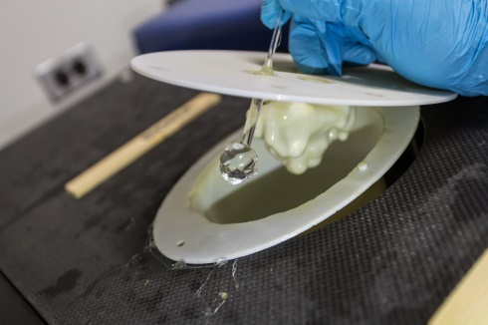

Figure 7 Assemble the two shells and the tumor before pouring any of the mixtures used for tissue emulation.

1. Fill the fibroglandular shell with the water-Triton solution, and the outer shell with a glycerin solution. Using a funnel will help to avoid any spills, make sure to clean and dry the funnel between each use to avoid any contamination.
2. To take a reference: remove the fibroglandular shell and the tumor (if present) and fill the outer shell with glycerin (or the selected soft tissue mixture). Then a reference can be taken.

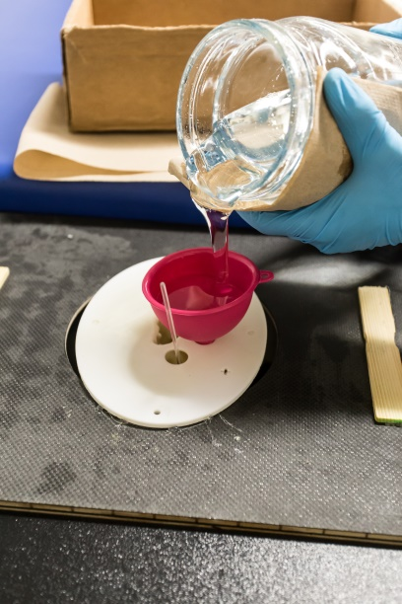

Figure 8 The 3D printed phantom is filled using the funnel, using paper towels to transport the containers would avoid any spillage. Make sure to keep the top of the bed system clean.

1. Once the experiments are finished make sure to dispose of the mixtures appropriately, **Triton X-100 cannot be disposed on the drain**. A used glycerin drum is used for this propose; once the drum is filled it can be disposed properly by contacting the right person. Every lab member should take a WHMIS course offered by the university, where more information on waste disposal is sheared. More information for waste disposal and WHMIS courses can be found at <http://umanitoba.ca/admin/vp_admin/risk_management/ehso/chemical_safety/index.html>

A third shell is in development to create a skin like surface for the 3D printed phantoms.

### VNA Calibration.

In any measurement, there are uncertainties, which are manifested as a deviation of the measurement when compared with the true value. There are two types of uncertainties. Type A uncertainties are random measurement errors that cannot be systematically corrected. These errors can be statistically modeled. Type B uncertainties are reproducible and are systematic. These errors can be corrected.

While type A uncertainties are not systematic, some of them can be avoided. Thermal drift is a type A uncertainty that occurs when the device suffers a temperature change. Materials change dielectric properties when there is temperature change. Thermal drift would alter the performance of the system over time. To achieve thermal equilibrium a warm up period for VNAs is recommended before using them. As part of our calibration procedure a **half hour warm-up period** for the VNA is necessary.

The calibration process measures the phase delay introduced by the cables used to connect to the antennas. The VNA under use should be calibrated at least daily to ensure the measurements are correct.

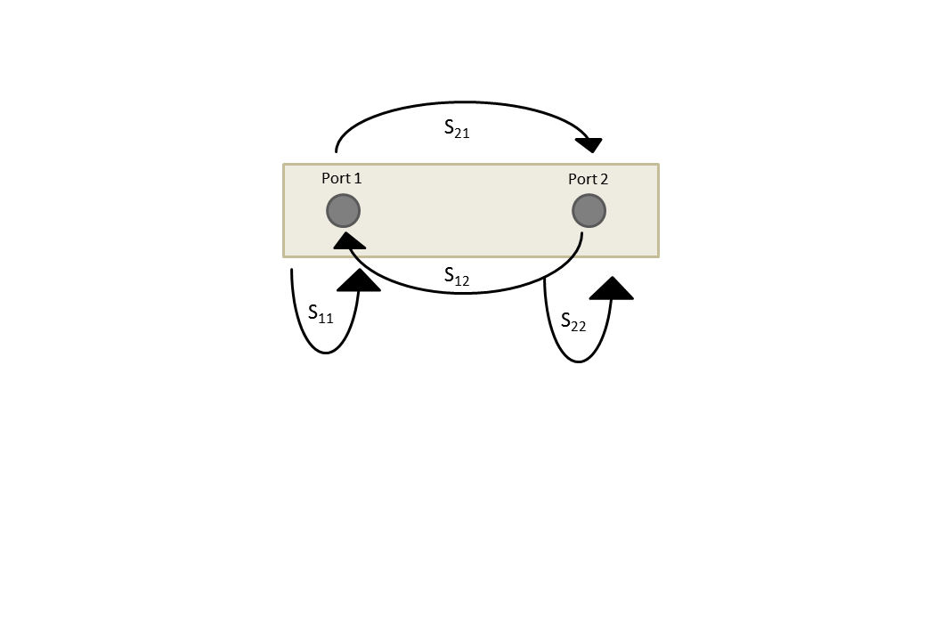

Figure 9 S-Parameters for a two-port VNA, when sending a signal from Port 1 to port 2 it is known as S21, S11 and S22 refer to measurements done with open ports where there is a reflection of the wave at the termination point.

#### Planar 804/1

The bed system uses the Copper Mountain Planar 804/1 VNA. This VNA is controlled entirely through a computer interface. The program can be downloaded from:

<http://www.coppermountaintech.com/products/2/804.html>

There is also a copy of the program in the lab shared folder at:

\\192.168.1.10\lab\software\VNA\planar804

The Planar 804 software includes a simulator that can be used for testing.

The lab folder also contains the Planar 804 documentation at:

\\192.168.1.10\lab\Lab Documentation\VNA\PLANAR804\

An up-to-date version can be found in the same webpage as the software.

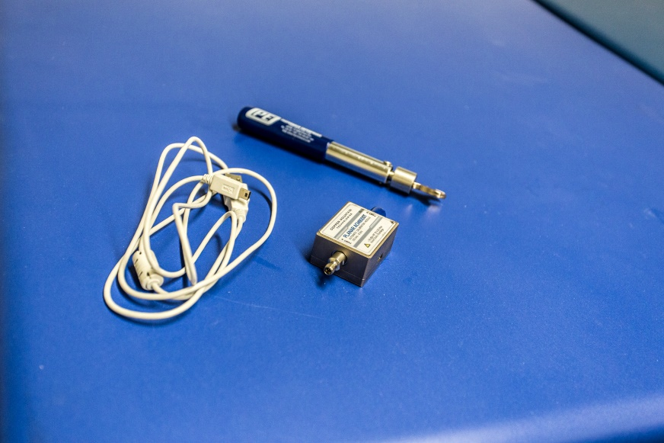

Figure 10 Calibration kit ACM8000T, click type torque wrench, USB cable,

To calibrate the VNA we use a calibration kit. There are two kits available, the ACM8000T by Copper Mountain, and the 85032E by Agilent (now known as Keysight). The ACM8000T requires a USB connection to control the kit and has a range of 300 kHz to 8 GHz at 50 ohms. The 85032E does not require a USB connection but it needs to change between the different types of loads. The range is from DC to 6 GHz at 50 ohms. The cables being used must match the 50 ohms impedance.

The calibration can be done following these steps.

1. Disconnect the SMA 3.5 mm connectors from the antennas and plug them in to the ACM8000T calibration kit.
   1. The wrench has a click preset at a torque of 8 in/LBS, once the torque is achieved the wrench would move and produce a click. **Do not overtighten the connectors** above this torque.
   2. The antennas can be set up at an awkward angle, when connecting and disconnecting be careful to not force the connectors or the thread may be stripped.

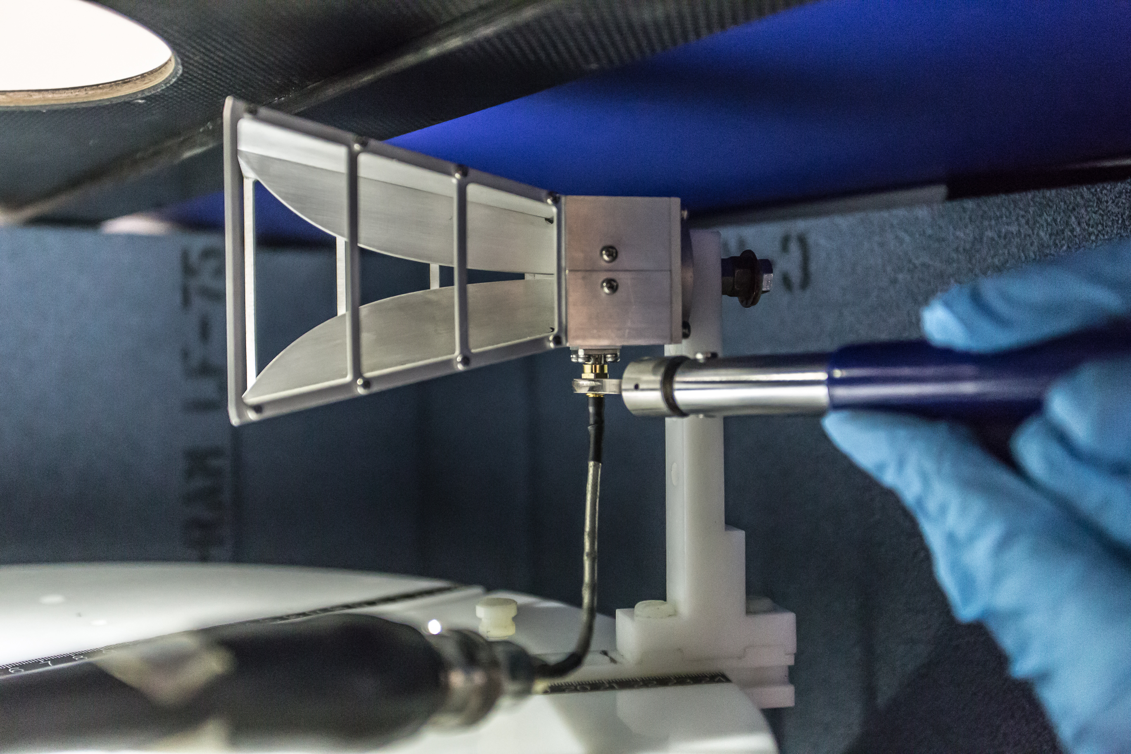

Figure 11 Use the wrench with the click torque to connect and disconnect the cables.

1. Connect the ACM8000T via USB to the computer
   1. The bed system has a spare USB cable already connected to the computer. It is at the top of the rack at the same level of the lift stage motor. It holds by a cable holder.

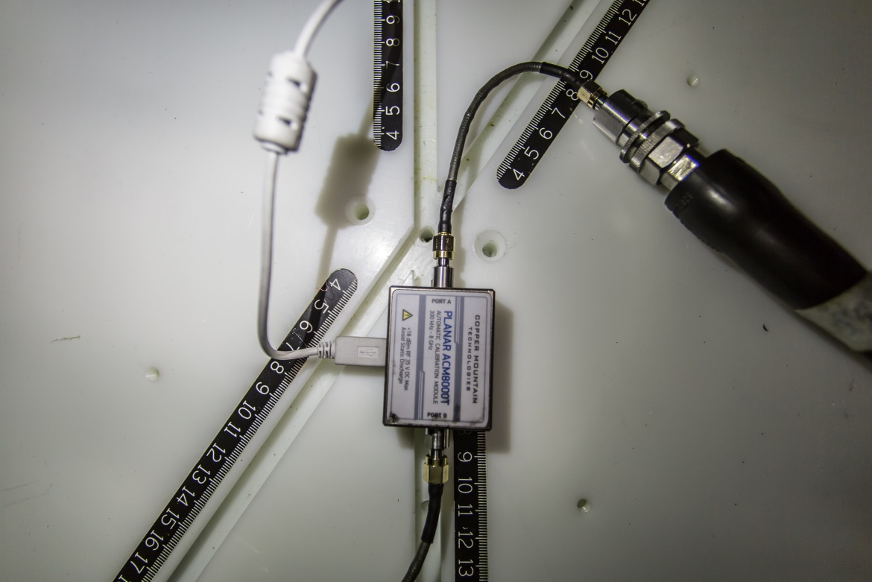

Figure 12 ACM8000T calibration kit with all the connections.

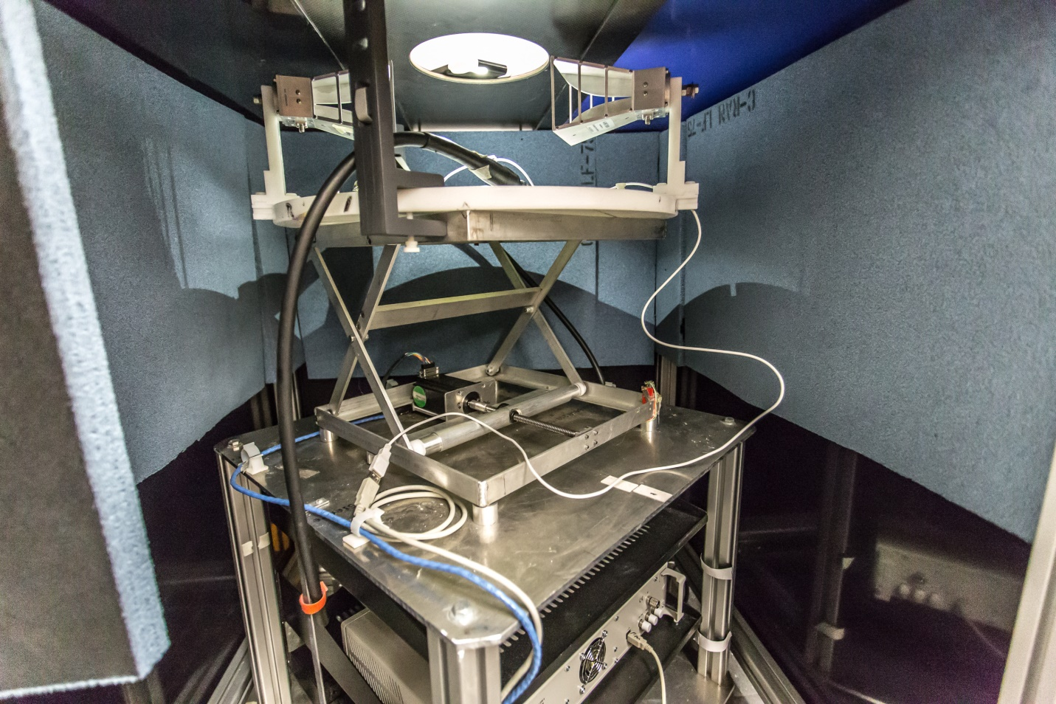

Figure 13 USB cable for ACM800T calibration kit.

1. Open the Planar 804 software, select calibration.
   1. Select auto calibration.
   2. Select the correct calibration kit (**SC8000**)
   3. Make sure **unknown through is ON**
2. To start the calibration selects the correct number of ports. The system will auto calibrate. This may take some time.

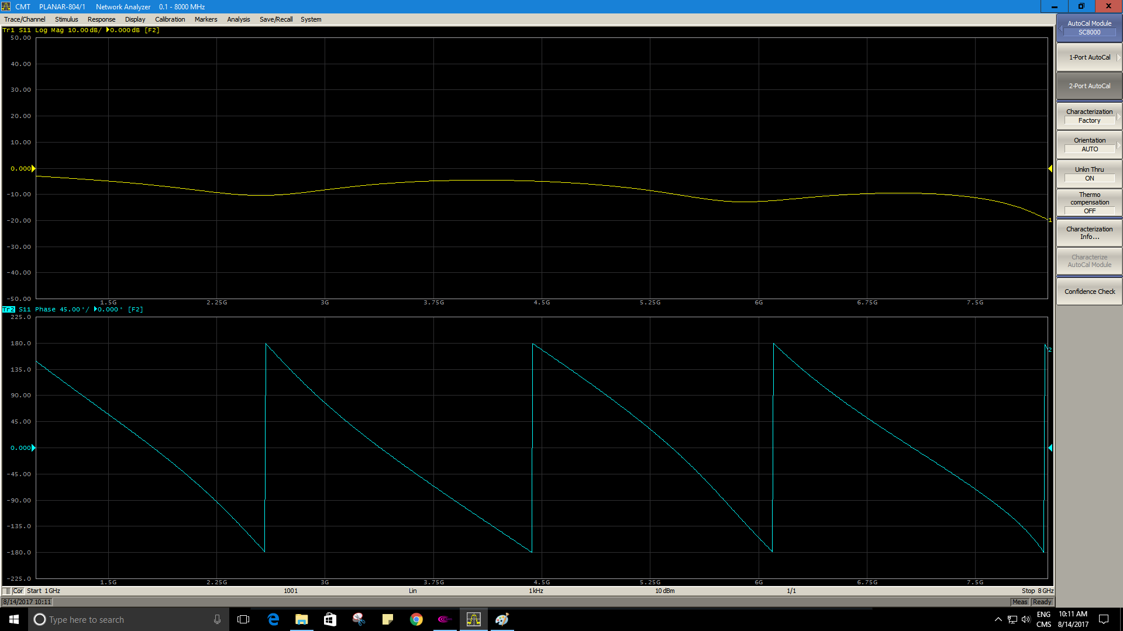

Figure 14 Settings for auto calibration, module SC8000, orientation AUTO, unkn Thru ON, Thermo compensation OFF. Use *2-port AutoCal* to start the calibration.

1. Once the calibration finishes you can test the calibration by doing a confidence check, the VNA will generate a known signal and will plot an outline on how it should look. The confidence is an iterative process so it may take some time for it to finish.

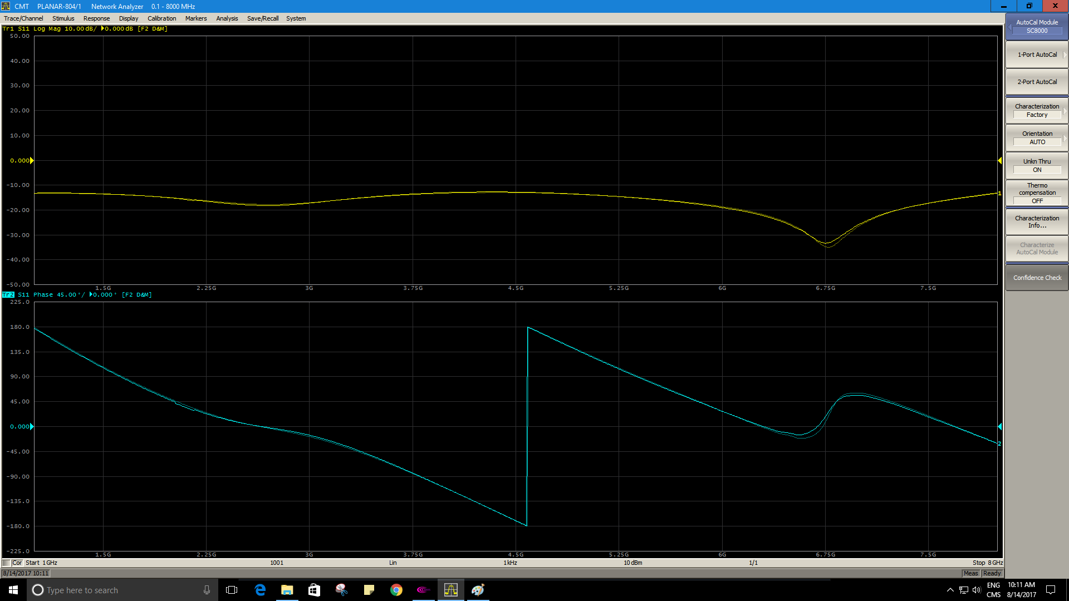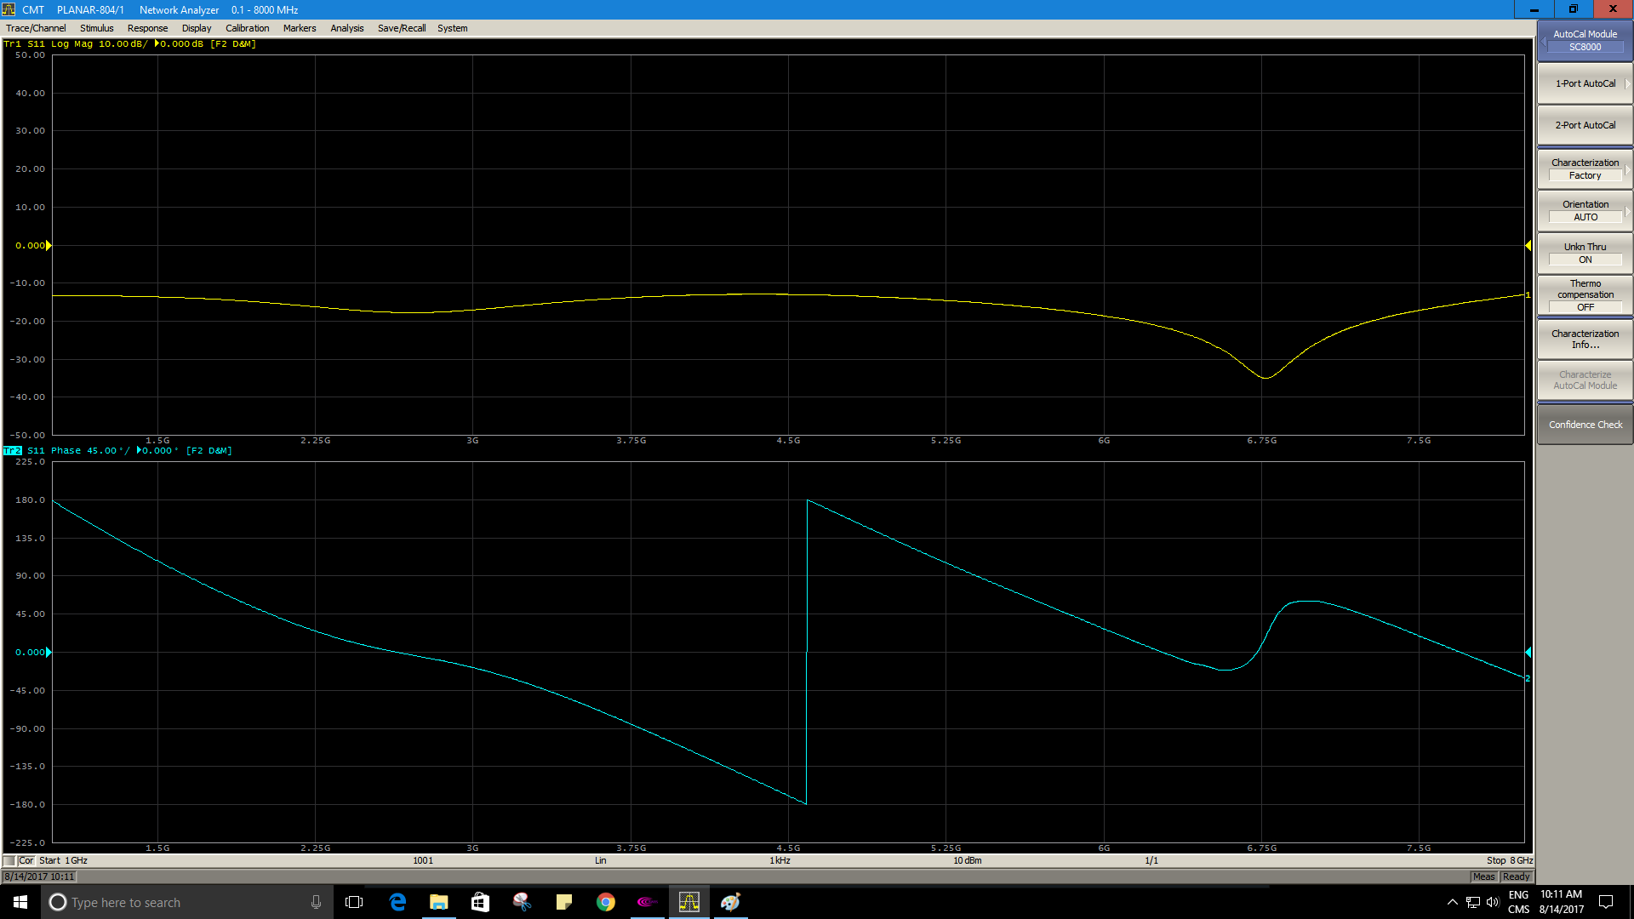

Figure 15 Top: poor confidence check results — note how the outline is not perfectly aligned at 6.75 GHz. Bottom: More accurate confidence check results — the outline is aligned with the measured signal.

1. Disconnect the ACM8000T from the system and plug the antennas back in. Be careful not to apply excessive force. The click torque tool will mark when the torque is right.

#### Fieldfox N9923A

The lab also has a Keysight Fieldfox N9923A VNA. The calibration procedure for this VNA can be found in the documentation of it.

<http://www.keysight.com/en/pdx-x201782-pn-N9923A/fieldfox-handheld-rf-vector-network-analyzer-4-ghz-and-6-ghz?cc=CA&lc=eng>

There is also a copy of the manual file on the lab shared folder

\\192.168.1.10\lab\Lab Documentation\VNA\fieldfox\

The Fieldfox VNA is calibrated using the 85032E calibration kit. This calibration kit uses a N-Type to SMA converter to plug in to the cable used to feed the antennas. When doing the calibration set up choose the correct calibration kit and the correct adapter on the VNA menus. The

### Bed system set up and BMR software

**If at any point there is a problem with the bed system use the red emergency stop button on the side of the bed system. This will cut power to all equipment.**

The bed system has a rotary stage to rotate the antennas around the scan location. The rotary stage is controlled by SC300-1B motion controller. The lift stage motor is controlled by an IMC23-L01 stepper motor.

The IMC23-L01 stepper motor was manufactured by RMS technologies, the company is no longer in business and the documentation for the motor cannot be found online. The documentation for the rotary stage and the lift stage is on the lab shared folder:

\\192.168.1.10\lab\Lab Documentation\Motor

**NOTE: The lift stage must be configured when first powered by using the “Send Home” option on the stage control window.**

The bed system is controlled by an HP computer using a custom made program in C# called BMR. The program has an icon on the desktop.

To start the system make sure the power is on, the system has an emergency button that cuts the power to all the equipment. There is also a power strip at the bottom of the main system rack.

The system communicates with the Planar 804 VNA trough the main application of the VNA. It is recommended that the Planar 804 software is running when the BMR program starts.

When the BMR software starts, it tries to connect to the different equipment of the bed system.

**Laser Client**: There is an optional laser measurement tool. This would be used to map the shape of the breast. To use the laser tool the server should be running.

**VNA**: The system would try to connect to the specified VNA. If the Fieldfox VNA is chosen the connection is done thought the TCP/IP network. For the Planar 804 VNA a USB connection is used, to control the VNA the S2VNA software should be running, if it is not the BMR software will start it.

**Lift stage**: The BMR attempts to connect to the lift stage using a serial connection (COM7 or COM8). A USB to RS323 converter is used.

**Rotary stage**: The BMR attempts to connect to the rotary stage using a serial connection (COM7 or COM8). A USB to RS323 converter is used.

If any of these connections fail, the system will show a warning message. It is possible to attempt a connection once the BMR software is running. It is also possible to take a scan without all system connected.

#### BMR software overview

The system has two main views:

**Standard view**: This is the default screen. It is used to take a standard measurement using the last settings saved. In this view the only option is to start a scan, and to stop the scan. It also offers the option to save the patient ID.

**Administrator view**: This view offers the option to change all the settings of the system. It is the view most used to take experimental scans.

To access the administrator view, click on View>Administrator, the system will ask you for a password, the password is **radar**

The system would generate special file names using the following pattern: <Ref>_<type>_<chosenName>_(xxcm)_<domain>_<month>_<day>_<year>_<hourminutes>.

Where the prefix *Ref* would be added for reference measurements. <type> would be Mono for S11 measurements and Multi for S21 measurements. <chosenName> is the name chosen by the user. (xxcm) indicates the position of the lift stage. (0cm) is when the lift stage is at the top. <domain> indicates if the file is on the frequency domain (freq) or the time domain (time). The last part of the file name (<month>_<day>_<year>_<hourminutes>) indicates the time and date of the file creation.

The main administrator screen allows you to configure every part of the system. The screen is divided in 5 different sections.

**Reference**: This section is used to record a reference for the system. A reference is a single reading of the anntennas that would be later substracted from the recorded dataset. **This option is not used with bed system.** The bed system rotates the antennas and requieres a reference for every scan postion, the reference option in the BMR software only allows for a single measurment. This set up is useful for the bench top system, where the antennas do not move. The options of this section are:

**Move lift to Position**: This option is not directly related to the reference. The menu has different preset heights for the lift stage. The 0 option is as high as the lift stage is programmed to go. Every option moves the lift stage 1 cm bellow. **NOTE: for this menu to work well the lift stage must be configured by using the “Send Home” option on the stage control window.**

**Record Mono Ref**: This option will record a single S11 measurement. It would open a safe file dialog to allow you to select a file location and a file name. When this option is used it would automatically load the recorded reference and subtract it from all subsequent sweeps.

**Record Multi Ref**: This option will record a single S21 measurement. It would open a safe file dialog to allow you to select a file location and a file name. When this option is used it would automatically load the recorded reference and subtract it from all subsequent sweeps.

**Record Mono and Multi**: This option will record an S11 and S21 measurement. It would open a safe file dialog to allow you to select a file location and a file name. When this option is used it would automatically load the recorded reference and subtract it from all subsequent sweeps.

**Complete Ref Rec**: This option will record an S11 and S21 measurement. This option will not open a save file dialog. Instead it would use the default reference path to select the save location and it would create a new folder on this path. The file name would be generated by the system. When this option is used it would automatically load the recorded reference and subtract it from all subsequent sweeps.

**Recall Mono Ref**: An open file dialog would open allowing the user to select an S11 reference file to load. The loaded file would be subtracted from all subsequent sweeps.

**Recall Multi Ref**: An open file dialog would open allowing the user to select an S21 reference file to load. The loaded file would be subtracted from all subsequent sweeps.

**Loaded MonoStatic Reference:** This message will indicate the file name and path of the S11 reference. If no reference was recorded or loaded it would be empty.

**Loaded MultiStatic Reference:** This message will indicate the file name and path of the S21 reference. If no reference was recorded or loaded it would be empty.

**General Settings:**  This section shows the type of system being used, the default paths, and the type of scan being saved.

**Setup mode**: This would allow the user to select a system to use. Bed is the bed system, while Experimental is the bench top system where the antennas are fixed and the phantom is moved.

**Save path**: The default path to save the sweep files. This is the path where the save dialog would open by default.

**Reference path**: The default path to save the reference files. This is the path where the save dialog would open by default.

**Scan Mode:** This would select the type of scan. MonoStatic will only save S11 measurements while MultiStatic would save S11 and S21 measurements.

**VNA Settings:** This section has a description of the current VNA settings. The Start VNA option will attempt to connect to the selected VNA. The change settings will open a new window to change the current VNA settings. The Planar 804 is connected through a USB cable, so the IP address is a loopback address. The Fieldfox VNA is connected via TCP/IP so the VNA address is needed.

**Number of data points**: The number of data points to measure over the frequency range. While this apply for both frequency and time domain the VNA takes all the measurements in the frequency domain and then converts the resulting vector to the time domain.

**Average**: Is the number of measurements the VNA will average in each scan position. An average of 10 is recommended.

**Stage settings**: This zone shows the settings for the lift and rotary stage.

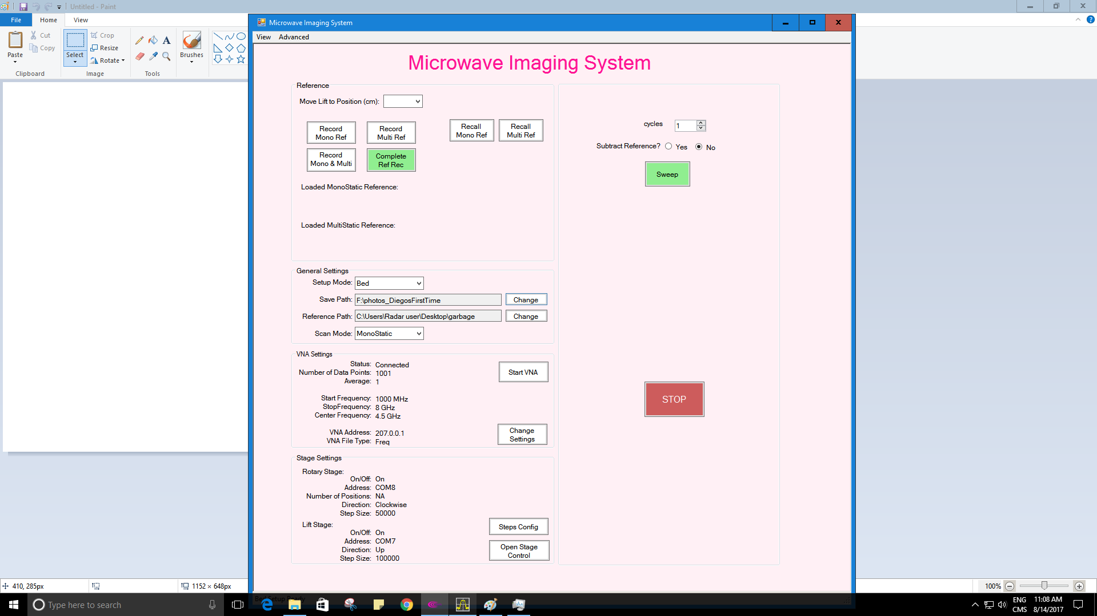

Figure 16 Advanced view of the BMR system. It allows the user to change all the settings of the bed system.

##### Stage Control Window

**If at any point the lift stage is moving against the top of the scan chamber use the red emergency stop button on the side of the bed system.**

The stage control window is can be access by pressing the “Open Stage Control” button on the administrator view interface. This window allows for configuration of the rotary stage and the lift stage.

This menu is useful to connect to the lift stage or the rotary stage when the BMR is not configured with the correct COM port.

The lift stage is controlled by a stepper motor. When the motor is turn on the current position of the motor is 0. However for the bed System we consider the 0 position to be at the bottom of the lift stage range. To configure the correct position, the lift stage must be calibrated using the “Send Home” button. The lift stage will find the home position when a switch at the bottom of the lift stage is pressed see figure 17.

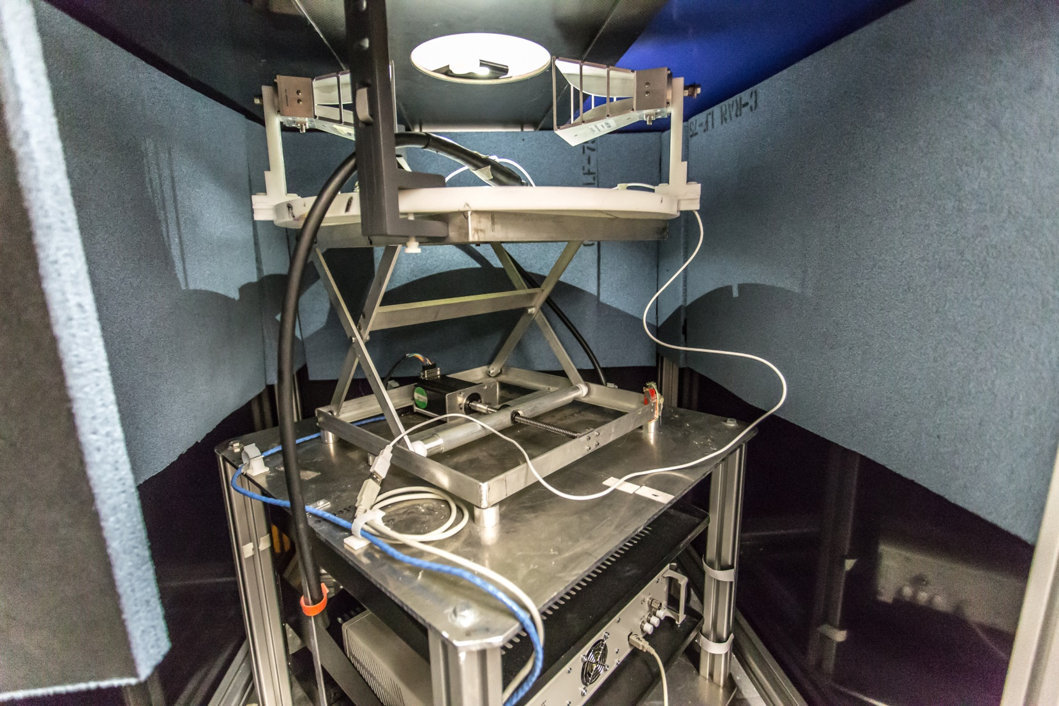

Figure 17 Home switch for the lift stage. When configuring the lift stage the switch will mark the bottom part of the movement range. To configure the lift stage the Stage Control window has a “Send Home” command.

The initial configuration of the lift stage follows these steps.

1. Power on the lift stage. Every time the lift stage losses power it will need to be configured again.
2. Open the BMR software. The software should connect to the Lift stage on start, if there is an error a warning message should appear.
3. Open the administrator view. Click on the “view” menu and select “Administrator”. The default password is “radar” without quotes.
4. Open the Stage Control window. At the bottom, there is an “Open Stage Control” button.
5. Check the lift stage is connected. When the lift stage is not connected all the options on the Stage Control will be gray. Except the menu to select a COM port. To connect the Lift Stage, select the correct COM port from the menu.
   1. If there are no COM ports listed, make sure all the USB to SERIAL converters are connected to the PC
   2. The program expects a response from the Lift Stage motor, if there is not response then the BMR software will not stablish the connection. Check the motor is powered on and that the correct COM port is selected.
6. Press the Send Home button once. The Lift Stage will move looking for the home switch.
7. The motor will look for the home position, if the motor does not find the home switch it will stop after a while. If the motor has not gotten to the home switch press the “Send Home” button again until the home switch is reached. (see figure 17 for the home switch position).
8. Once the home switch is reached the motor will move in the opposite direction until the switch is no longer pressed. The lift stage will be configured correctly.
9. To move the lift stage back to the top of the system close the Stage Control window, and select the 0 option on the “Move Lift Stage to position” menu at the top of the advanced view.

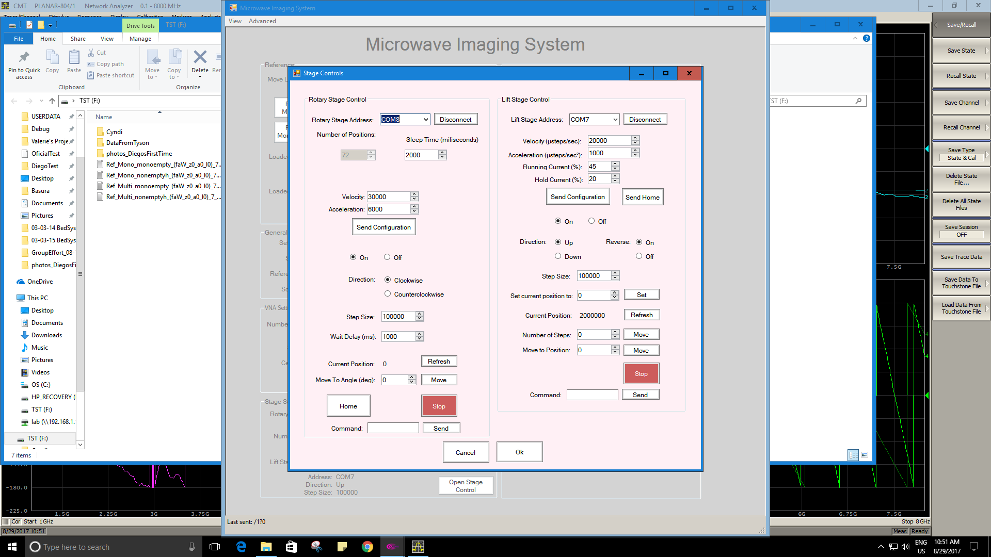

Figure 18 Stage Controls Window. This settings window allows for configuration of the rotary and lift stages. If the Current position of the lift stage is 0 then the lift stage needs to be configured by using the “Send Home” button.

##### Scan locations configuration

To configure how many scan locations are using during a scan the “ConfigSteps” window is used. This window is opened by the “Step Config” button.

This window is divided in two tables. The left table shows the positions of the lift stage and the right table shows the number of scan locations and the number of lift stage positions to be used during a scan.

##### Lift Stage Steps.

This table has two columns. The CM column is filled automatically by the software. The “pos” column can be modified by the user. The “pos” column has the number of steps the lift stage motor will be from home.

The 0 position marks the top of the scan chamber and normally is at 2 000 000 steps from the scan position, but this may need to be changed depending on the weight on the system. The next position would be at 1 900 000. Since the lift stage travel is not linear the number of steps needed to move 1 cm may change as the position is lower. At the top of the system 100 000 steps would be close to 1 cm shift in the lift stage.

If no change on position for the lift stage is desired the same number can be used for all the columns. The CM column would correlate with the level column on the Rotary steps table.

##### Rotary steps

The rotary steps table has two columns. The level column is related to the CM column on the lift stage table and is generated by the system. The steps column can be changed by the user and it shows how many scan locations there is around region of interest.

The number of rows represents how many times the system will scan around the region of interest (ROI). If there is only one row the system will do one scan of the specified steps. If there are 2 rows the system will do two rotations around the ROI, one clockwise and the second counter clockwise. Every row will move the lift stage to the next position on the Lift stage table. If the position is the same on the lift stage, then there won’t be any movement in the Z direction.

The number steps can be anywhere from 1 to 180. The upper limit is related to the hard stop of the rotary stage. The rotary stage has a hard stop in the home position; it is possible for the system to jump this hard stop if the system keeps rotating clockwise. Once the rotary stage jumps the hard stop it is not possible to rotate counter-clockwise. This will cause the cables to twist beyond the intended tolerance. For this reason, it is important to always return the system home once a movement is done.

At the bottom of the Rotary steps table there is the option to add or delete rows. Even numbers of rows are preferred. To avoid twisting the cables the first scan will be done clockwise and the second scan will be done counter-clockwise. If there are an odd number of rows the system will return the rotary stage motor home at the end of the scan. Returning the rotary stage home will take some time and it may be best to use an even number of rows to use the time better.

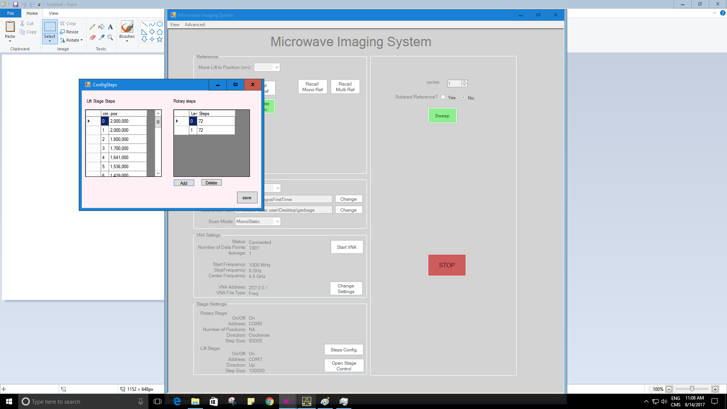

Figure 19 ConfigSteps window. The left table is used to configure the number of steps for the Lift Stage. The right table shows how many scan locations lift stage positions are going to be used for the scan. The “cm” column and the “level” column are related. In this example the level 0 scans is taken at position 2 000 000. The level 1 scan is also taken at 2 000 000, this means the lift stage will not move. This is useful to get two scans of the same phantom for repeatability.

##### BMR Configuration file.

The BMR software stores its configuration on an XML file (config.xml). The file follows a similar organization as the advanced view. If there is a problem using the interface to change a setting it is a good idea to change the configuration file first and then run the BMR software.

To save any changes done to the configuration access the advanced view, then on the administrator menu use the save changes option. This menu also offers the option to change the password for the administrator view.

### Performing a scan using the bed system.

Before performing a scan using the bed system make sure the following points are covered:

* The Phantom is ready to be used. Make sure the liquids inside the phantom do not have any bubbles that may offer additional scattering.
* The VNA has been calibrated. The BMR software is connected to the VNA and the correct settings are loaded (frequency range, average, points)
* The bed system has been set up. The lift stage has been configured using the send home option. The number of steps and levels has been set up.

To do a scan:

1. Press the green “Sweep” button.
2. A save file dialog will appear, select the directory to store the information. Remember that the files will be saved using the following naming template
   1. <Ref>_<type>_<chosenName>_(xxcm)_<domain>_<month>_<day>_<year>_<hourminutes>
3. The system will start the scan. Two progress bars will appear. The first bar will show the overall progress, while the second bar will show the progress on the current lift stage position.

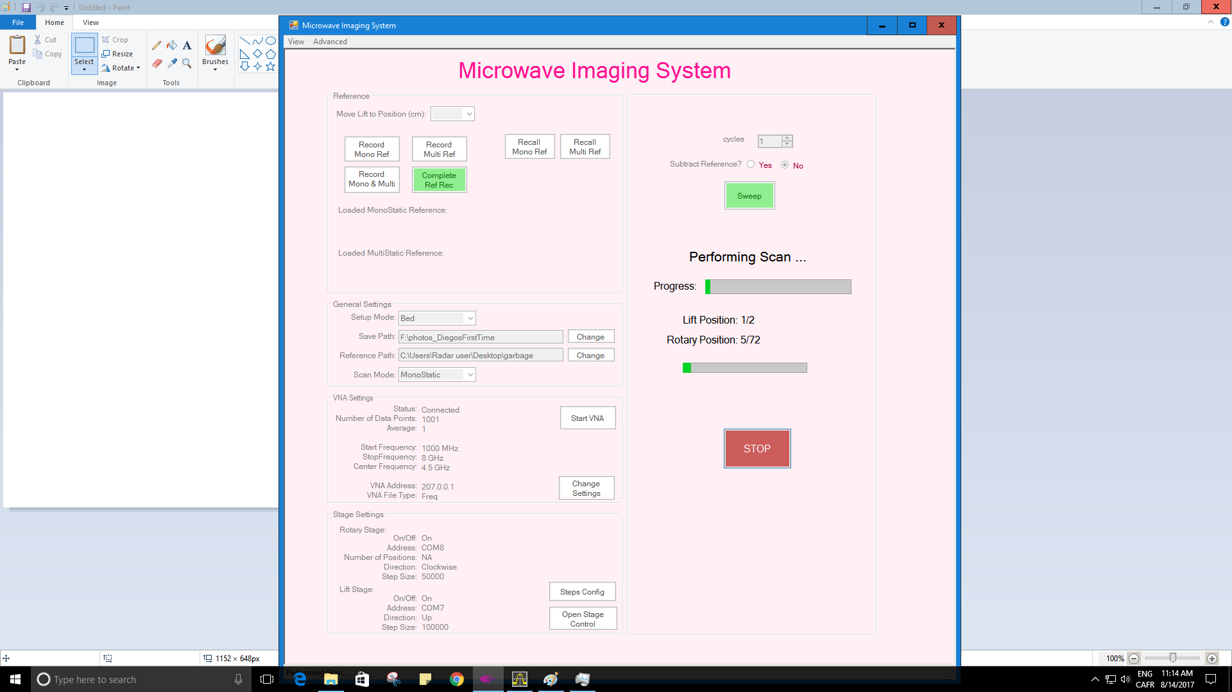

Figure 20 BMR screen during a scan. The top progress bar is a general progress. While the bottom bar shows the progress on the current lift position.

1. At the end of the scan a message will appear with the time it took to take the scan.

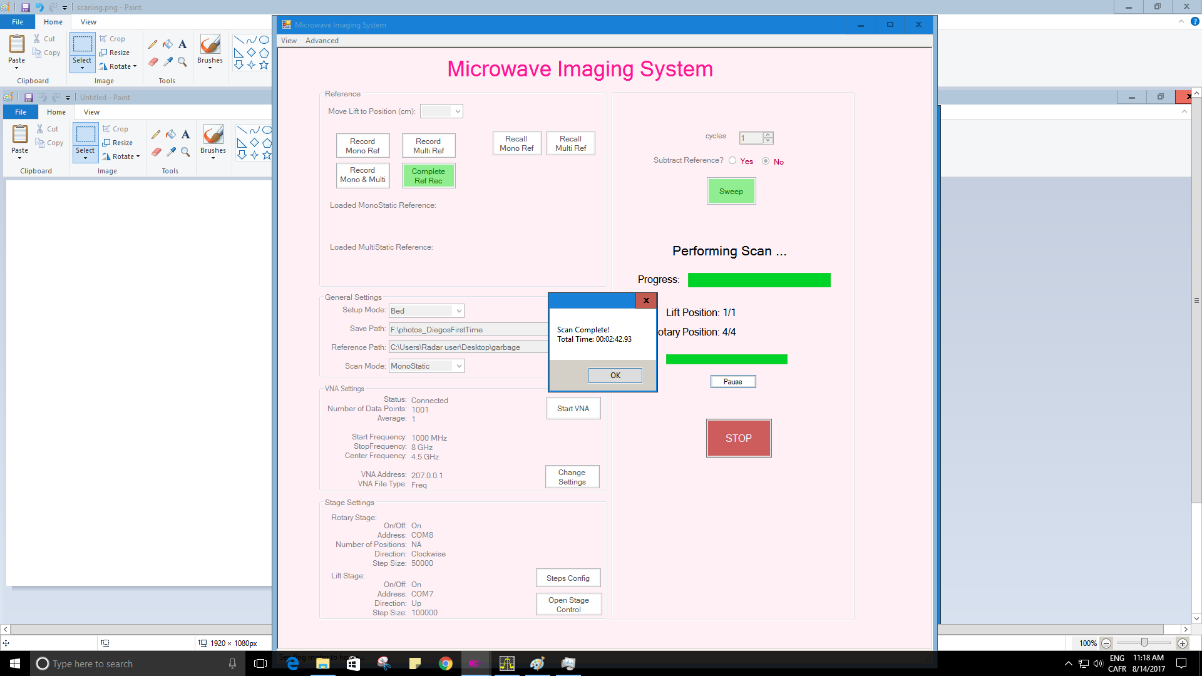

Figure 21 Message at the end of a successful scan

If a reference is needed the same steps can be taken. There are two types of references. An empty chamber reference takes a scan without any phantom. A phantom reference uses the phantom without any targets inside.

# Reconstruction

To do a reconstruction we use a waveform reconstruction algorithm developed in matlab.

The files for the reconstruction can be found at:

\\192.168.1.10\RadarReconstruction

There are 4 folders in this path.

**exampleFiles:** Have 2 example scans taken in the bed system. The scans use the semispherical phantom. One of the examples is in air, with only targets. The second example uses a glycerin phantom with two targets. See Figure 22

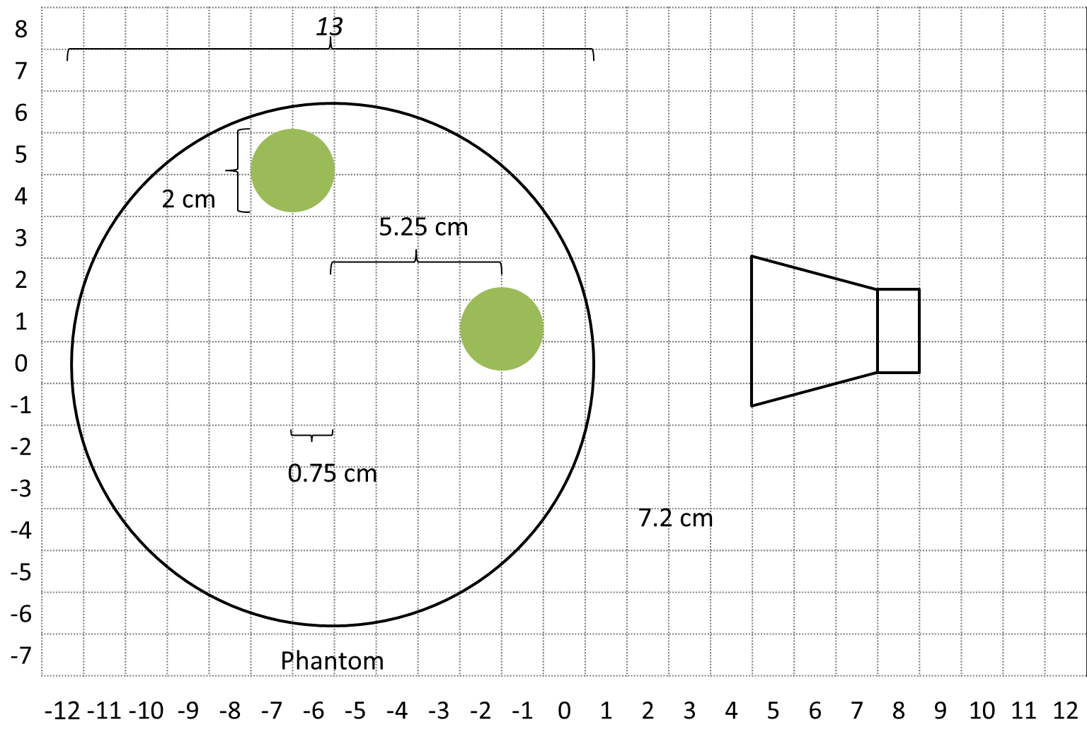

Figure 22 Example scan included to demonstrate image reconstruction, the scan was taken using the bed system and the hemispherical phantom. It contains two targets separated by 90 deg.

**Multistatic**: Has all the files needed to create a reconstruction of the files. The example.m script shows how to do a reconstruction.

**Simulator**: Contains the files used to do a microwave simulation.

**speedSearch**: Contains the files used in the speed search algorithm for reconstruction.

## Import datasets

The first step of the reconstruction is to import the datasets to Matlab. The datasets are stored in a text file with tab-separated values. The number of columns in the text file is equal to double the number of scan locations. For a 72 scan location scan there are 144 columns on the text file. The data sets are complex numbers, the odd number columns are the real part and the even number columns are the imaginary part.

To import the data sets to matlab the Matlab *importdata* command can be used. This will generate a matrix from the text file. The imported data will not be in complex form. To convert the matrix to the complex number we use the data_reader.m script. The script can be found on:

\\192.168.1.10\RadarReconstruction\Multistatic\data_reader.m

## Reconstruction Script

The main reconstruction script is Multi_rec_full.m. This script takes a single structure as a parameter and returns a structure with the reconstructed image.

An example on how to use the Multi_rec_full function can be seen in the Graph_Multistatic function. This function takes all the parameters needed for a reconstruction and it displays the reconstructed image. It also returns the original structure returned by Multi_rec_full and an additional variable with the distance vector in meters for the reconstructed image.

The parameters needed for reconstruction using the Graph_Multistatic.m function are:

**Speed**: This is the speed of the light in the medium, in m/s. If targets are in air the speed is the speed of light in vacuum. The speed can be calculated from the relative permittivity by following this relationship:

$$C_{n}=\frac{c}{\sqrt{ε_{r}}}$$

**Radius**: The radius of the scan geometry. To approximate the radius measure from the edge of the antenna to the center of rotation. Each antenna introduces a phase delay of the signal, this will add to the time travel of the wave to the center of our ROI. Add the phase delay of each antenna to the measured distance from the center of rotation. The following table shows the phase delays of the antennas in our lab:

|  |  |
| --- | --- |
| Antenna Type | Phase delay |
| Vivaldi | 0.14 m |
| Brass horn | 0.10 m |
| Commercial horn | 0.148 m |

If a new antenna is used the phase delay needs to be calculated. See section 2.3 of [2] for details.

**Data sets**: The datasets taken from our scan. The system has the ability to take a multistatic scan. The function accepts both **s11** and **s21** datasets. If a monostatic reconstruction is to be used an empty vector in s21 should be used. The function applies a Tukey window to the datasets before reconstruction. This function can be changed on the ApplyWindow.m script.

**Frequency range**: This represents the frequency range of the VNA. Normally the datasets taken in the bed system use a range of 1 GHz to 8 GHz. The function assumes that the frequency range is linearly spaced.

**Angle**: The angle between the antenna for s11 and the antenna for s21, in degrees, default is 145.

**Final Image size**: This is the value of the number of pixels in the final image. By default the reconstruction algorithm returns an M x M image where M=2*(Frequency points). For 1001 frequency points we get a 2002x2002 image. However only the center of the image contains the data we are interested in. This parameter allows us to only take the region of the image that has the targets.

A full working example on how to do a reconstruction can be found on:

\\192.168.1.10\RadarReconstruction\Multistatic\example.m

Running this script should produce the following images:



Figure 23 Example images from the radar reconstruction algorithm. Left a dataset taken in Air. Right a dataset taken using a glycerin phantom.

The axis of the images is in Meters. If the location of the files changes the path should be changed. In this example a reference is extracted from the dataset. For the dataset in air an empty scan chamber was used a reference, for the dataset with a glycerin phantom a glycerin phantom without targets was used as reference.

## Speed Search

In some cases calculating the speed of the wave for a reconstruction can be a challenge. An speed search algorithm was developed as an aid. The details of the speed search algorithm can be found in [2].

The speed search algorithm reconstructs the radar datasets over a range of speeds and then it analyses each image using image quality metrics.

The algorithm takes the similar parameters to the ones used for reconstruction. In addition the speed search algorithm takes a speed range and a number of points in that range as a parameter. The algorithm will perform a linear search over the speed range. It creates an image for every data point.

An example of the speed search algorithm can be found in:

\\192.168.1.10\RadarReconstruction\speedSearch\example.m

This example will look for the speed in the example scans used before. The algorithm may take up to 10 minutes to run depending on the computer being used. On a computer with an Intel core i7 and 8GB of ram it should take about 5 minutes.

At the end of the example file it will print the optimal speed using different quality metrics. One of the more reliable metrics is the Sobel metric. The example file will also plot the behavior of the image quality metrics over the selected speed range.



Figure 24 Speed search results graph. The speed search algorithm evaluates 6 metrics. In this case the peak for most metrics is between 2.6e8 and 2.75e8 m/s. **note that the entropy is the only metric where the minimum value is used**.

The example file uses 100 data points between 1.5e8 and 3e8 m/s to search for the speed. In some cases this can be reduced to save time. When using a glycerin phantom on the bed system the search range can be between 2.3e8 to 3e8 m/s using 60 points. When using datasets where there is a matching medium (like oil) a range between 1e8 to 2e8 m/s may be more appropriate.

# Appendix A

Dielectric properties table.

|  |  |  |  |
| --- | --- | --- | --- |
| **Material** | $ε_{r}$**(1.5 GHz)** | $ε_{r}$**(4.5 GHz)** | $ε_{r}$**(7.5 GHz)** |
| Glycerin | 9 | 6.6 | 6 |
| 90% Glycerin 10% water | 11.8 | 7.9 | 7 |
| 80% Glycerin 20% water | 21.2 | 11.3 | 9.2 |
| 70% Glycerin 30% water | 25.8 | 13.1 | 10.4 |
| 60% Glycerin 40% water | 43.5 | 23 | 16.4 |
| 50% Glycerin 50% water | 52.8 | 32.1 | 22.5 |
| **Material** | $ε_{r}$**(1.5 GHz)** | $ε_{r}$**(4.5 GHz)** | $ε_{r}$**(7.5 GHz)** |
| 40% Glycerin 60% water | 60.4 | 43 | 31.2 |
| 30% Glycerin 70% water | 65.9 | 52.8 | 40.8 |
| 20% Glycerin 80% water | 69.2 | 59.3 | 48.1 |
| 10% Glycerin 90% water | 75.4 | 70.7 | 63 |
| Water | 77.5 | 74.5 | 68.5 |
| Canola oil | 2.8 | 2.7 | 2.6 |

|  |  |  |  |
| --- | --- | --- | --- |
| **Material** | $ε_{r}$**(3 GHz)** | **Material** | $ε_{r}$**(3 GHz)** |
| Low-density breast tissue | 9 | Glycerin | 7.29 |
| Fibroglandular tissue | 25-37 | TX-151 polymer | 35 |
| Tumor | 55 | Saline mixture | 53 |
| Styrene-acrylonitrile | 2.5 | Canola oil | 2.6 |
| Cellulose acetate butyrate | 2.9 | Water | 76.3 |

# References

[1] Glycerine: an overview. (1990). [ebook] New York: The Soap and Detergent Association. Available at: http://www.aciscience.org/docs/Glycerine_-_an_overview.pdf [Accessed 24 Aug. 2017].

[2] Rodriguez Herrera, D. (2014). Antenna characterisation and optimal sampling constraints for breast microwave imaging systems with a novel wave speed propagation algorithm.